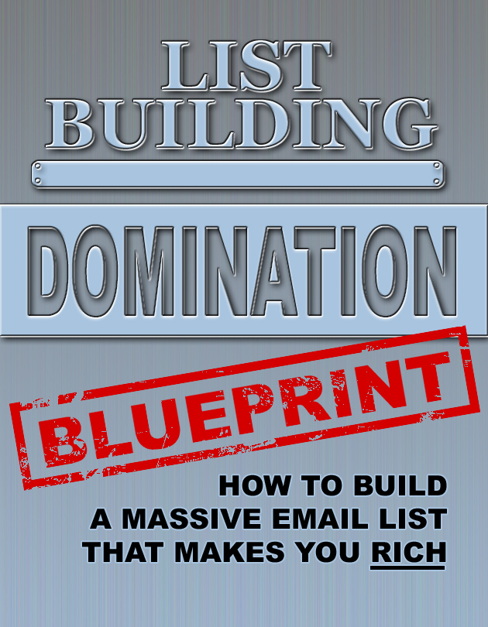

INTRODUCTION
You casually wake up on a late Friday morning, after plenty of rest. You needed the rest after seeing your favorite band in concert last night. The music was phenomenal. The food and drinks at the restaurant beforehand were incredible. You and your friends had a blast.

Your friends had to get up early for work, but you knew you could sleep in as late as you wanted to. You drink your morning coffee. You check your email. You even catch up with a couple of shows on your DVR. You aren’t stressed. You’re relaxed, and you take a moment to just appreciate the life you’ve created for yourself.

Now, some days you love to get up and work for eight hours straight. You feel great when you put in a hard day’s work, but last night you had already decided that this isn’t one of those days. Today you want to take it easy. You want to have some more fun, yet you still plan on making some money.

You start browsing the latest products on the affiliate site that you frequently visit. You’re looking for a product that will really help the 20,000 people on your main email list. There’s the perfect product. You’ve been researching it a lot over the last few days, and you’ve made up your mind that your list of subscribers can really benefit from this product. Today will be the day that you tell them about it. This product has a high EDC, or earnings per click, so you know the sales page converts well.

You type up a fun and informative message to your list. You give them a couple free tips like you usually do. You then begin to explain to them what this product can really do for them. At the end is your call to action and your affiliate link. You’re done. All of this took less than an hour.

You spend your day doing the things you love to do. You might go to your regular surfing spot, or you drive up to the mountains, and the powder is just right for a great ski or snowboarding session. You could go see that new movie everyone is talking about before meeting an old friend for lunch at that new downtown restaurant you’ve been wanting to try. You might just want to relax at home and finish your favorite author’s most recent book. The choices are endless.

After a fun, event-filled day, you head back home. First thing you do is turn on your computer and check paypal. Today you’ve made $2,451. It’s certainly not the most you’ve ever made in a day, but not bad either. You expect some more money to come in from today’s product offer over the next few days.
You’re heading to bed early tonight. In the morning, you and your significant other are flying out to Hawaii for a long weekend. You make sure to pack your laptop in case you feel like staying an extra week. Now you can do some work right on the beach. It’s good to be the boss.

WHY YOU NEED A LIST
The story in the previous section is not a fantasy. Lot’s of successful, full-time marketers have days like that all of the time. I frequently have days where I make plenty of money while spending my time doing the things that I love.

So, why do you need a list? For starters, having a large and responsive email list is the fastest way to bring in massive amounts of money. Instead of having to figure out where you’re going to find new customers, you already have a large list of potential customers. In fact, many of them have probably already bought from you and are willing to buy again.

If you have created a new product, you can release it directly to your list and often it will make a lot of money on the first day. You can do the same with a great affiliate product. If you regularly promote extremely valuable and high quality products to your list, subscribers will buy them. It’s that simple.

Eventually, you will start to think of your list as an ATM. Need money for that cruise you’re taking next month? Find a product through an affiliate program to sell for instant commissions. Want to buy that car or motorcycle you’ve had your eye on for a while? Create and launch a product of your own.

If you are an internet marketer and you are not capturing email addresses for your list, you are leaving a lot of money on the table. Start building a list today, and take advantage of this amazing method. Don’t worry, I’ll walk you through and show you the secrets of exactly how I build my lists.

GETTING STARTED
If you don’t have one, you are going to sign up for an autoresponder service. This is the service that enables people to subscribe to your list. You can send out automated emails, or just broadcast when you want to. You can even manage people into different lists and choose which lists to email. My favorite, and one of the most popular services, is Aweber.com. You can sign up to try it for a month and it only costs a dollar. There is really no excuse not to be building a list when you can start out for only a dollar. Once you have an Aweber account, watch the video tutorials and familiarize yourself with how it works. You just need a basic understanding. When it is time to actually start building your list you, you will learn pretty fast with a hands-on approach.
Now you will need a website. You can make one for free if you’re just starting out. You can use blogger or weebly to make free sites. If you have the money, I highly recommend getting some hosting and eventually you will need a domain name. Your domain name can be the name of your overall marketing company/media group, it can be your own name for branding purposes, or it can even be the name of your product.

WHY YOU NEED YOUR OWN PRODUCT TO BUILD A LIST
You need your own product because it’s important to give potential customers an incentive to join your mailing list. You won’t get many people to sign up by just saying, “Hey you! Sign up for my mailing list and I’ll send you stuff to buy!” Instead, give them something of extreme value in exchange for their e-mail address.

The key is that the product needs to help the people you are targeting. If you are building a list in the weight loss market, then give them a product that tells them how to lose weight! It is a common mistake for new marketers to hold back on their free giveaway products. You can always come up with more products later.

If you give a potential customer an amazing product for free that solves their problem and gets results, they will have no problem paying for products in the future. If the product is of such incredibly high quality, they will be eager to pay for another product down the road. You want your customers to be thinking to themselves, “Wow, if this is how amazing the free product is, I wonder what I can expect from a paid product!”

HOW TO MAKE A PRODUCT
If you’re new to IM, chances are that making your own product sounds like an intimidating task. It is not that difficult. If you can read and write, then you can make a product. I’m going to show you exactly how to make a product of your own.

Another concern I often hear is that people say that they aren’t a big name expert, so they aren’t qualified to create a product of their own. You don’t need to be an big name in the industry to create a product of value. All you need to do is give the prospect the right information so that they can get the results they want. That is it! If your product can help people get the results that you promised them, then it is a good product.

Before you make your product, you need to decide what your product will be. If your market is weight loss, create a product that explains a good weight loss diet plan and give sample meal recipes. If your market is dating and seduction, then make a product based around overcoming the anxiety of approaching a woman at the bar. Do you see the pattern here? Solve a major problem for people in that market and keep it simple.

Now that you know what your product will be, you need to research it. Pretend that you have that same problem, and go seek the information online. Go to article directories like ezinearticles, or find youtube videos, or just do a simple google search. Find at least five good sources of information and study it. Take extensive notes. While you’re learning you will probably come up with more ideas for products in the future. Write those ideas down for later use.

You might be thinking at this point that if it is that easy to get this information for free on the Internet, why would somebody want my product? People tend to be lazy. People don’t want to find multiple sources and study for a few hours. They want a quick fix. They want information conveniently laid out in front of them. That’s what you’re going to do. You’re going to compile all of the useful information, and give it to them in an easy to follow, step-by-step guide.

There are three common forms of free products that are given away to build a list. Short reports, videos, and audio files. I’ll tell you how to make each kind of product. When making your first product, just choose the type that you think will be easiest for you to make. If you like to write, do a report. If you like to talk, do an audio or video presentation.

Writing a report is easy. There are three basic parts to a report. The introduction should state what problem the report is going to solve for the client. Then there should be a step-by-step guide to solving that problem. Separate each step into it’s own section. Finally, the conclusion should just paraphrase everything that was in the step-by-step section. Eight to ten pages is plenty for a free report, but if you need to write more, go for it. Stay away from adding fluff just to add to your page count. It will be much more valuable if you just get right to it. If you want, you can make the first page a cover by coloring the background and writing the title in a big font.

If you want to make a video you can do it two ways. You can either just get on camera and speak in front of it, or you can download some free screen capture video software like Cam Studio and do a PowerPoint-style presentation with a microphone. Getting in front of the camera is nice because it automatically starts to create a relationship with the viewer, and it builds massive trust. Whichever you decide, make sure to follow the same guide as the report. Introduction, step-by-step, conclusion.

To make an audio file you can just record your voice talking about the same stuff you would in the video. Another popular way to make an mp3 giveaway is to have somebody interview you about the problem you’re solving, almost like you’re coaching that person. It can be more exciting and will also give you credibility as an authority on the subject.

The most important part about your product is that you need to make sure it works. It must be able to actually solve the problem. If you’re in the make money online market, and you are claiming your product shows you how to sell products from ClickBank, then you should make sure you’ve actually tested it and sold products from ClickBank. Same goes for other products. If you make a report on dog training, test it by helping a friend train their dog.

SET UP A WEBSITE FOR YOUR PRODUCT
Now that you have a product, it’s time to set up a website. If you have the money to get some hosting and a domain name, you should do that now.
We’re going to be giving away this product to people and in exchange they are going to be signing up for your list. So, the main page of this website is going to be the opt-in page. An opt-in page is basically like a mini-sales page for your free product, with an opt-in form somewhere on the page.
The copy of this page basically just needs to talk about your free product, and mention how it can help this person. A standard format for writing this kind of copy is:
This is what I have. Tell them what your product is.
This is what it does. Explain what the product is all about.
This is what it can do for you. Show how this benefits them.
This is what I want you to do next. Tell them to opt-in to your list.

Aweber, or whatever autoresponder service you’re using, will have a way to make your opt-in form that you put directly on your webpage. This is where the lead will put in their name and email address to get their free product. Once they input their information, they are now on your list. Your autoresponder will direct them to a page of your choosing.
I have the autoresponder send them to a simple thank you page. Here I tell them that I thank them for their interest, and that their free product will be sent to them in a couple of minutes. Then I tell them that while they are waiting, I want them to take a quick look at something that I think can really benefit them. This is where I pitch a one time offer, either a product I have created, or an affiliate product.
You should always have a one time offer. There is no sense on leaving money on the table when they may be willing to buy right from the beginning.
Now you must make sure to set your autoresponder to send out an email instantly after someone has opted-in to your list. This email should have a link to wherever you are hosting your free product so that they can download it.

DRIVE TRAFFIC TO YOUR PRODUCT’S WEBSITE
Now that you have your website up and ready to go, you need to start sending traffic to it. The more targeted traffic you get to your site, the more people will be signing up to your list.
There are plenty of ways to get traffic to your site, I’ll cover a few of the more popular ones here:
SEO means search engine optimization. This is optimizing your website to rank as high as possible in the search engines. If you hit the number one spot for a highly-googled key phrase that has to do with your niche, you can expect a lot of traffic. This also involves a lot of backlinking which can be a huge undertaking if you do it yourself.
PPC ads or pay-per-click ads, are when you are paying per person that clicks on an advertisement leading them to your page. Google is the most common place to set up PPC ads, and it should be your main focus if this is what you are going to be doing. Just make sure that you endlessly test variations of all your ads to maximize your conversions.
Forum advertising is when you join a large public forum that has to do with your market. You participate in the forum, contribute to discussion, and try to give as much helpful advice as possible. In your forum signature, you should have a link to your free product. The better reputation you have on the forum, the more likely people will be to click on your free product offer.

Email ads can be a great way to grow your list fast. Essentially, you are paying people who already have large lists within your market. These people then promote your free offer to their list. You can usually work out an arrangement where they need a minimum number of clicks that must go through to your page. If they can’t provide that minimum, then they have to keep running the ad until they do.

Remember, you don’t need to stick to just one form of traffic. You can try them all and see what works best for you. You can then focus on the one or two that seem to bring in the most leads.

GET OTHERS TO BUILD YOUR LIST FOR YOU
This is one of my favorite methods to list building and I’m still surprised by how few people do this. This is basically another traffic method but with a twist.
Instead of creating a free product, think about expanding it a little more and setting a small price for it, somewhere between $7 and $14. Now instead of driving traffic to your offer, you are going to get others to drive it for you.
Post your offer on some affiliate sites that allow you to set your product at 100% commission. You’ll attract a lot of affiliates this way. Now they are sending people to your list, and you don’t have to spend any money. They’re building your list at no cost to you.
The greatest thing about this method is that you are building a list of proven buyers. Proven buyers will be much more likely to buy your one time offer, and any other offers you send them down the line.

HOW TO TREAT YOUR LIST
Now that you have started to build an email list, you can’t just start bombarding them with affiliate offers every day. You need to build a relationship with your list. You need to build trust. If you do this, then you will get a much better response when you send them offers. If you treat your list the wrong way, they will be quick to unsubscribe and all your list building efforts will have been a waste.

So to build a relationship with your list, you should be regularly sending them quality content, for free. It doesn’t have to be a lot. Just a few free tips here and there, something that will help them. After a few emails like this, then send them an offer.
A good formula to follow is three emails of content, one email that is an offer, and repeat this over and over.
Try not to email too often, this will have a negative effect. Nobody wants their inbox blowing up from the same person twice a day. Personally, I don’t like to send an email more than every three or four days. I would make sure to send an email at least once a week though. If you wait too long between emails, your relationship will get cold and they won’t be as responsive to your offers.

GETTING THE MOST MONEY OUT OF YOUR LIST
Now you’re on your way to building a massive list. Here are a bunch of different ways to make money with your list. To maximize your income, you should be trying all of these to see which ones your list responds well too.
Affiliate offers - Find affiliate offers that are appropriate for your list. Make sure that whatever you promote, that it is a high quality product and that the sales page converts well. Also, make sure that it is something that your email list will actually want. If you have a list in dog training, they might be interested in a product about dog grooming, but they will probably be more responsive to a product that teaches advanced dog tricks.

Product launches - Make your own products and launch them to your list! You’ve already learned how to create your own products, take it to the next level. Create a larger product and launch it to your list. Whatever you sell will be 100% products. After launching it to your own list, you can get affiliates to sell your product for 50-75% commission. Personally, I give out 75% commission to any product that costs less than $100 and 50% commission to any product that costs more than $100.

One time offers and upsells - With every single offer you send, make sure there are upsells and one time offers. At least a single one time offer, but you can do three or four. Every time someone buy a one time offer they now are redirected to the next highest tier offer. Each higher tier should be a higher price than the last one. If you are promoting an affiliate offer, make sure you get commissions on all upsells and one time offers.

Recurring income - Create a membership site or promote a membership site as an affiliate. You then get recurring monthly payments from each person you sign up to be a member. Anytime you can get a subscriber to commit to a recurring payment, it’s amazing for your income.

Email ads - As long as the offers are of high quality, you can let other people advertise to your list. This involves them paying you a flat rate price and in return you send out a broadcast to your list promoting their offer. This is usually a free product for the other person to build their list, but it may also be a product with a small price if they are trying to build a buyers list.

CONCLUSION
So, there you have it. You now have all the information you need to start building your email list. Just remember that list build is an ongoing project. You should always be list building. A list is a consistent traffic source that you have available to you, and you should always be trying to make that traffic source larger and larger.

Treat your list right, and they will treat you right.

